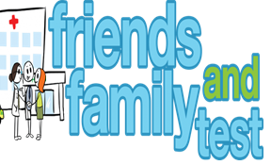
HAVE YOUR SAY TO IMPROVE YOUR CARE!
COMPLETE OUR SHORT QUESTIONNAIRE ON HOW LIKELY YOU ARE TO RECOMMEND OUR SURGERY TO FAMILY AND FRIENDS.
We have been collecting your replies and below are our results for
December 23
Very Good | Good | Neither Good/nor poor | Poor | Very Poor | Don’t Know
26 | 4 | 0 | 0 | 0 | 0

Recent comments:
- Service here is always fabulous

- Excellent surgery giving an old-fashioned service, and prompt appointments on offer. BRILLIANT!!
- Always get an appointment when needed.
Excellent practice all round

- Treated with compassion and empathy

